Proxy Server

Manual

Installation
- Open a terminal
- Go to the files direction
- Write “make”

Uninstall
- Open a terminal
- Go to the files direction
- Write “make clean”

Run the proxy
- Open a terminal
- Go to the files direction
- Write “java proxy <port>” were the port is specified to any given port.

Add/Remove forbidden word(s)

- Open the file ”connection.java in a text editor
- Find the line ”ADD/REMOVE FORBIDDEN WORDS HERE”
- Adding:
Write ”add_bad_words( "A_FORBIDDEN_WORD" ); ” on a line under the line above for adding a new forbiden word there ”A_FORBIDDEN_WORD” is the new forbidden word.
Removing:
If you would like to make a forbidden word legal, simply remove the line
add_bad_words( "A_FORBIDDEN_WORD" ); there A_FORBIDDEN_WORD is the word you wish to make legal.

Features

2. Handles simple HTTP GET interactions between client and server;
done in file ”connection.java”
line 47, void run(). The void run is initiated in ”proxy.java” when we receive a new connection( in the while(true) loop, line: 18 ) and do a ”.start()” on it.

3. Blocks requests for undesirable URLs; using HTTP redirection to display this error page insteas compatible with all major browsers (e.g. Internet Explorer, Mozilla Firefox, Google Chrome, etc.) without the requirement to tweak any advanced feature
done in file ”connection.java”
Line 61 calls the funktion ”get_host” which call bad_url, if the url is bad , the function get_host will return ”-1”. We then do a check if the host is ”-1”. If it is, we load the page that will tell the user that the url say that the page is bad and then close all streams and sockets.

6.Is compatible with all major browsers (e.g. Internet Explorer, Mozilla Firefox, Google Chrome, etc.) without the requirement to tweak any advanced feature
Since the HTTP protocol has a standard are all the browsers sending request in the same way which mean that the proxy handels request in the same way independetly what browsers the users use.
7.Allows the user to select the proxy port (i.e. the port number should not be hard coded)
done in file ”proxy.java”
Line 8, an if statement check if there was an argument then the program was started, if not, it print out a help message and shutdown .

8.Is smart in selection of what HTTP content should be searched for the forbidden keywords. For example, you probably agree that it is not wise to search inside compressed or other non-text-based HTTP content such as graphic files, etc.
done in file ”connection.java” line 97
There is an if statement that see if is_html is true. We only sniff the content if it was true. is_html was set in the GET-request were we checked if we sent ”accept html” or not, if we did is_html was set to true.

Debugging
The proxy will print out a message in the terminal when its reaching a special function, when a bad_word has been found, etc ( see picture 1 ).

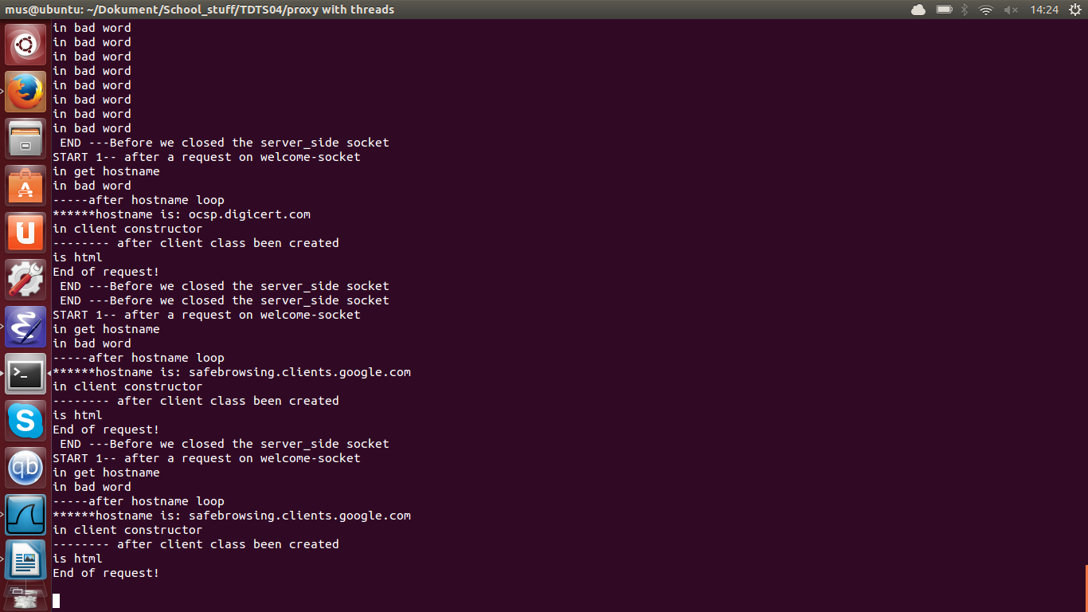
With this prints have we been able to debug the proxy.

Picture1

Summary of the proxy features
- Can load(most) web pages
- Can filter out content/ URLs based on our filter
- Currently have no limit for amount of threads
- Allows the user to choose what port he/she would like to use for the client/server communication between client and proxy
- Can not cache web pages
- Closes the connection between proxy/web server after each transmission has been completed

